**Contracts**  
All projects cannot be executed with in-house resources and the project manager has to requisition extra-organizational resources for the execution of the project. When a project manager has to get things done with resources over which he has no direct authority, it becomes necessary to acquire the required authority in some considerations. Such an arrangement can be termed as a ‘contract’ and the authority so acquired as ‘contractual authority”.

**Business Contracts**  
A contract as such as an agreement between 2 or more parties in writing, to do or not to do certain things. Business contracts are those agreements which are enforceable at law.  
  
A consideration is made in return for a specific promise contained in the offer of the promisor. In order to enter into a contract, there must first be an offer or proposal signifying the willingness of one party to do or abstain from doing something at the desire of the other party. The desire of the other party is expressed in the enquiry often known as Notice Inviting Tender (NIT) and the offer to carry out the services at certain terms is known as tender.

**Sequence of events resulting in a business contract are shown below:**

Enquiry 🡪 Offer 🡪 Acceptance 🡪 Agreement🡪 Contract

**Enquiry -**Issue of NIT to selected parties or to the newspapers by the project authority and sale of tender document.

**Offer-** submission of the tender documents by the bidder.

**Acceptance-** Communication from the recipient of the offer to the bidder indicating intent to enter into an agreement and acceptance of the same by the bidder.

**Agreement-**offer and considerations as accepted given a legal form and content duly signed by competent authorities of both parties. **Contract-**Consists of an agreement on stamped paper, a detailed letter of intent with agreed variations and original tender documents.

**3R’s Contracting**

**3R’s in the case of contracting are:**

Responsibility

reimbursement and

risk.

**Responsibility:**The issues of the responsibility are:  
1. What to parcel out to the contractors and what to retain.  
2. How to define the work parcels so that the contractors know their scope precisely and there is no overlapping, undefined, unallocated or ambiguous work area.   
3. What are the relevant performance parameters for fulfilment of which contractors must assume responsibility?   
  
Sometimes, the owner may not like to define everything clearly in order to keep some flexibility with him to play with the scope of work. The contractor may also not be interested in a clear definition so that he can latter make extra claims and earn disproportionately high reimbursement for any additional work. But in the interest of both parties, ambiguities to be minimum. If the ambiguities are more, this lead to evasion of responsibility, extra claims, ill-feeling, strained relationship, decay in work progress and additional cost in the completion of the project.

**Reimbursement**The second “R” of contract refers to the type of reimbursement. This “R” is more important for the contractor than the owner, while the owner may refer to the responsibility to describe the contract arrangement. The contractor may choose to refer to it by the types of reimbursement such as lump sum contract, item rate contract etc.  
Types of Reimbursement  
1. Lump sum contract  
2. Cost-plus contract  
3. Convertible contract  
4. Item-rate contract  
5. Hybrid contract

1. **Lump sum contract**In order to make a lump sum offer a contractor would like to have all the details. If the details are not know he would like to build contingencies in his price to take care of the unknown. Lump sum contract more expensive than a Cost-plus contract.  
    Lump sum - Fixed price  
    Negotiated- Fixed price is negotiated with the contractor.
2. **Cost-plus contract**In cost-plus contract, the owner agrees to cover the actual expanses of the project. These costs include labour, materials and other costs incurred to complete the work. The “plus” part refers to a fixed fee agreed upon in advance that covers the contractors overhead and profit. The cost-plus contract are “open book”, meaning the owner has the right to see exactly what the expense are. Cost plus contract are an alternative to lump sum contract that allow greater flexibility and more transparency for the owner. For contractor risk is reduced, because a cost-plus contract guarantees a profit.
3. **Convertible contract**In this type of contracts, initially works like a cost-plus contracts, after the scope of works defined and later converted to lump sum.  
     
   4) **Item rate contract**Item rate contract is also known as unit price contract or schedule contract. A contractor undertakes the execution of work on an item rate basis. He is required to quote rate for individual item of work on the basis of schedule of quantities furnished by the department. The amount to be received by the contractor, depends upon the quantities of work actually performed. The payment to the contractor is made on the basis of the detained measurements of different items of work actually executed by him.

**4) Hybrid contract**  
The contract in such cases may be divided into two parts,  
The parts where design parameter and quantities are frozen and are put on lumpsum.  
For the balance parts where quantities may change during detailed design, item rates are invited from the contractor.   
a) Lumpsum + item rate  
b) Lumpsum + Lumpsum + cost Plus  
c) Lumpsum + fixed rate.

**Risk**

Both the owner and the contractors are much concerned about Risk. In fact, a contract is considered to be an instrument for transfer of risk from the owner to the contractor. The contractor need protection from risk in one or other form. But the contractor risks only his fee. Small risks can be may be covered by insurance and little more protection may be provided by in the contract document.  
Owner Risk  
Contractor Risk

**Owner Risks**  
1. will the contractor be able to carry out the work as per specification?  
2. Can the work be completed within the quoted cost?  
3. Will the plant perform at the required level?  
4. Will the contractor stay on the job till its completion?  
5. Will the contractor adhere to the time schedule?  
6. Will the contractor cooperate with the owner and third parties?  
7. Will the party submitting the tender back out when the contract is awarded to him?  
8. Will the contractor rectify defects discovered after he leaves the scene?  
9. Will the contractor leave behind liability for the owner to deal with in regard to his staff or third parties?  
10 If the reltionship does not click, what can happen?

**Contractor Risk**

1. Will the owner terminates his work before completion of the same?
2. Will the owner make payments promptly?
3. Will there be work hold-up and and imposed idleness for him?
4. Will the owner carry certain obligations regarding his work?
5. Will the owner change the scope of work upsetting his plan and estimates?
6. Will the work quantities and specifications change significantly affecting his rate?
7. Will he get reimbursed for extended work duration?
8. Will there be price escalation and will he get compensated for the same?
9. Will he be penalized for failures beyond his control?
10. Will there be smooth cash flow?
11. Will the owner provide workforce and other inputs in time for uninterrupted progress?
12. Will the plant or equipment be taken over when ready?
13. Will the owner honor extra claims?
14. Will there be difference in interpretation of his scope and responsibilities with the owner?
15. Can he make a profit?

**Tendering and selection of contractor**  
A tender may be defined as an Offer to carry out certain work or supply certain materials or services in accordance with clearly detailed description and conditions.  
The Tendering procedure deals with:  
1. Prequalification of contractor  
2. Preparation of tender documents  
3. Mode of floatation enquiry   
4. Receipt of tender  
5. Guidelines for evaluation of tenders   
6. Selection of contractor

**Pre-qualification of contractors**

1. Contractor has had similar experience earlier and his performance.  
2. His past turnover and present financial commitments.  
3. He has the necessary infrastructure, adequate technical manpower, equipment and his present commitments.  
4. His credibility in terms his associates and associations with other agencies.

**Preparation of tender documents**  
A good tender documents will include the following  
  
1. Letter of invitation to tender  
2. Instruction to tender  
3.General conditions of contract  
4. Technical specification  
5. Special conditions of contract  
6. Scope drawing  
7. Bill of quantities  
8. General information about site  
9. Form of tender

**Receipt of tenders**  
The tenders may make a request to visit the site for further information. For supplementary queries, pre-bid conference may arranged for better information. The bids may be opened infront of the tenders present. The names of the tender would announced and recorded.

**Evaluation of tenders**The tenders are evaluated from technical, commercial, contractual and managerial angles. Normally, separate meetings are held with each contractor to obtain clarification and also to bring all the offers in line with the tender requirements.  
The lowest bidder who is technically and managerially acceptable is awarded the contract.

**Agreement**  
An agreement is now to be signed on a stamped paper. The form of agreement is probably the most standardized document.  
  
The accompanying documents normally are:  
1. Original tender papers comprising the conditions of contract, specifications, dates and other relevant information.  
2. Schedules of rates and prices.   
3. List of deviations from original tender stipulation   
4. Other relevant attachment

**Form of guarantee**  
Finally, a guarantee from sureties in the standard form may be asked from the contractor as an insurance against uncernties in dealings with the contractor.

**Tools and techniques in Project management**  
 **GANTT Chart (Bar Chart)**  
  
It is pictorial representation showing the various job/activity to be done and the time.

1. Activities involved in the project  
2. Start and end time of the activities

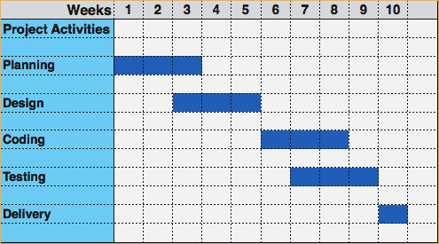

***Advantages of Gantt chart***  
1. Simple to understand  
2. Easy to change  
3. Simple and least complex means portraying progress.  
4. Easy to identify specific elements that be either behind or ahead of schedule.

***Limitations***   
1. It Can not indicate interdependencies of activities. Some activities are depend on the other activities and some are independent.  
2. It can not show the progress of work  
3. It can not reflect the uncertainty and tolerances in the duration time estimated for various activity.

**Network techniques**  
Structurally, Network is graphical model depicting the inter-relationship between the various elements of the project work system.  
It propagates holistic approach, that is individually nothing can be achieved and only when all of us work together.   
Arithmetically, a network computes the time, cost and resource requirement for the project.  
It highlights the importance of each activities.

**Terms used in network**  
WBS: Break down the project into activities such that each activity is clearly identifiable and manageable.  
  
Activity: This is physically identifiable part of the project that consumes time and resources. It is represented by an arrow.   
  
Events(Node): These are the beginning and end of an activity.   
  
Path: This is a continuous chain of activities from the beginning to the end of the project.   
  
Activity-On-Arrow(AOA) diagram: A network with activities represented on arrows and events on nodes.  
  
 Activity-On-Node(AON) diagram: A network with activities represented on nodes. Arrows indicate only the interdependencies between them.

**Network construction**

1. Activities progress from left to right.
2. Each activity is represented by only one straight and solid arrow.
3. If two activities having same start and end nodes, show one of them separately with

dummy activity with dashed line.

1. An activity which shows the logical relationship between its immediate predecessor and

successor activities.

1. Arrows should not cross each other as far as possible.
2. Avoid curved arrows, dangling arrows and looping of network.

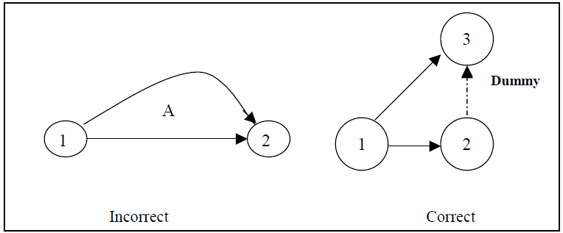

**Common errors committed in network construction**

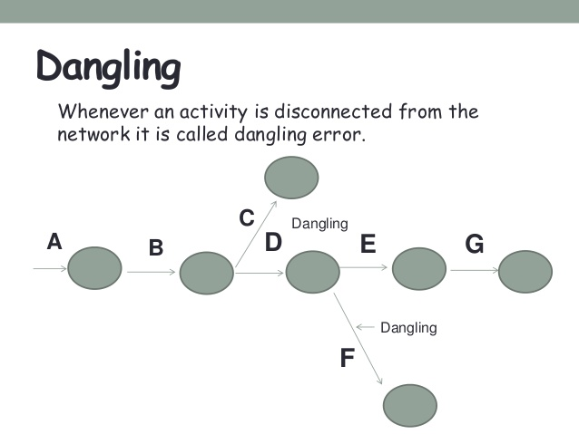 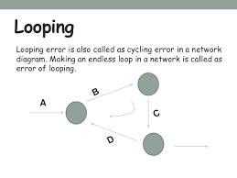

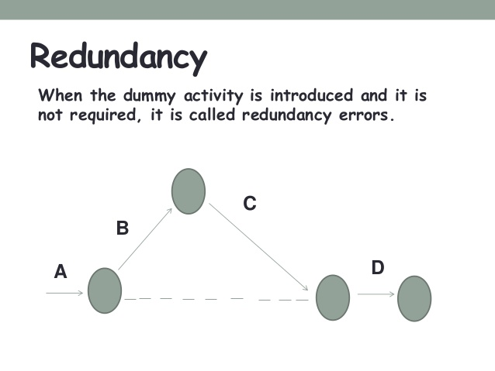

**Type of network analysis  
1. CPM (Critical path method) network  
2. PERT (Project evaluation review technique)**  
  
CPM does not incorporate uncertainties in job time, suitable for project activities having single time estimates. Determine the critical path, minimum project duration, floats available with each activity.  
  
PERT is suitable for non- repetitive projects, where job times are not estimable with certainty. So it is probabilistic nature

**Difference between PERT and CPM**

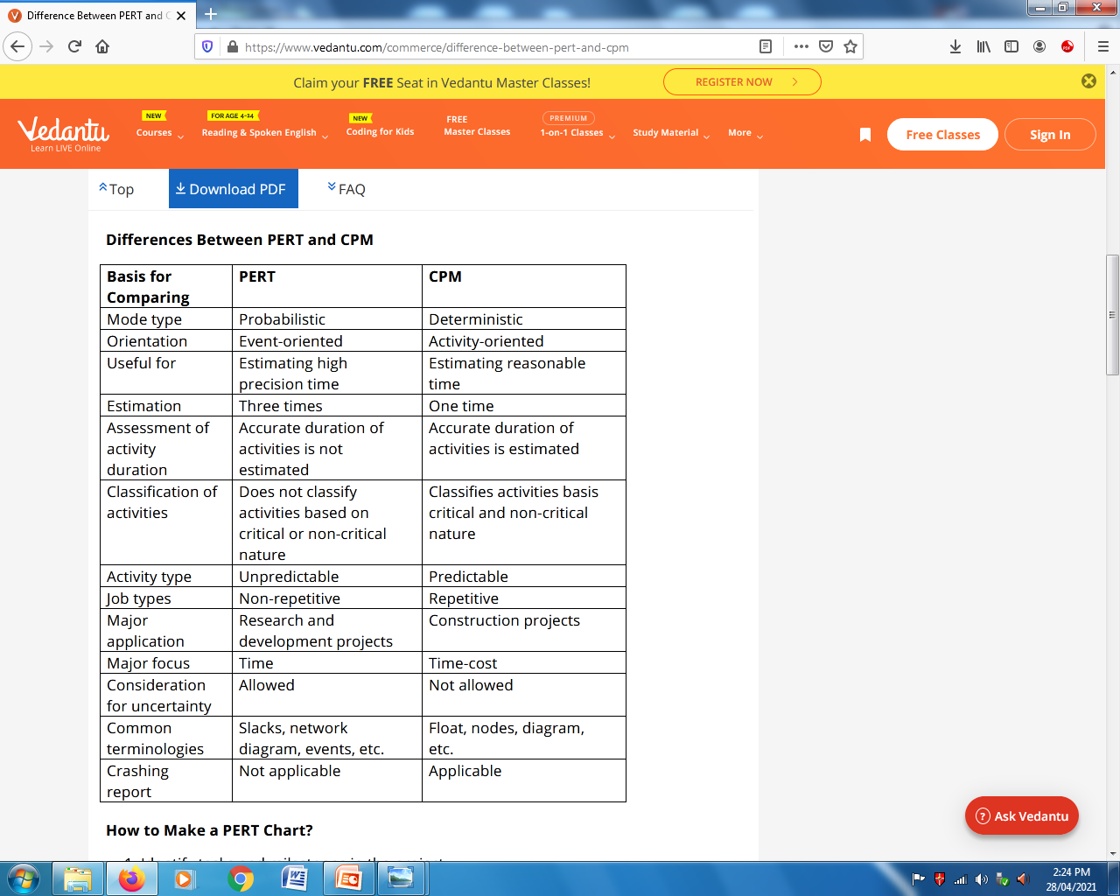

**Critical path**

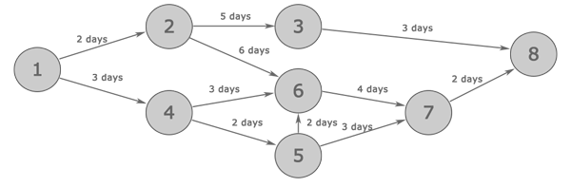

Paths

1-2-3-8 = 10 day

1-2-6-7-8 = 14 days (Critical path)

1-4-6-7-8 = 12 days

1-4-5-6-7-8 = 13 days

1-4-5-7-8 = 10 days

**Critical path:** This is the longest path time –wise connecting the start and end events. The events laying along this path are critical in the sense that their occurrence can not be delayed if the scheduled completion time is to be met.

**Earliest start and Late finish time**

**Early Start (ES)** of an activity in a project is the earliest possible time that the activity can start.

**Forward pass:** To determine the ES times of events, the computations stars at Node 1 and advances recursively to the last Node “n”.

**Late Finish (LF)** represents the latest date an activity can finish, without delaying the finish of the project.

**Backward pass:** To determine the Latest Finish times of events. The computations start at the last Node “n” and end at Node 1.

**Float/Slack**  
Float is the length of the free time available within the estimated times of the non-critical path. The float time is zero along the critical path activities

**Total Float (FT):** It is the amount of time by which an activity can be delayed without affecting project duration time.

TF=(LFj - ESi)-t

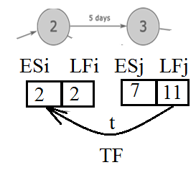

**Free Float (FF):** Free float is the how much an activity’s completion time may be delayed without causing any delay in its immediate successor activity.

FF=(ESj - ESi)-t

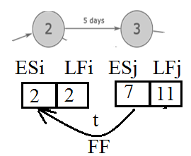

**Independent Float(IF):** It is the amount of time an activity can be delayed for start without affecting the completion of preceding activity.

IF=(ESj - LFi)-t

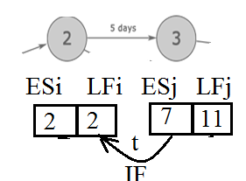

**Time estimates**   
After the network has decided, need to find time required for execution of each activity.   
  
Because of uncertainty involvement, difficulty to find exact time of activities.  
  
Three kinds of time estimates  
1. Optimistic time estimate (to)  
2. Pessimistic time estimate(tp)   
3. Most likely time estimates(tm)

1. Optimistic time estimate (to): This is the estimate of the shortest possible time in which an activity can be completed under ideal conditions.   
  
 2. Pessimistic time estimate(tp): This is the maximum possible time it could take to accomplish the job. If every thing went wrong and abnormal situations preveiled, this would be the time estimate for the activity.

3. Most likely time estimates(tm) : This is the time estimate which lies between the optimistic and pessimistic time estimates. It assumes that things go in the normal way, with a few setbacks, usual lapses in deliveries, no dramatic breakthroughs and so on.

**Beta Distribution**   
  
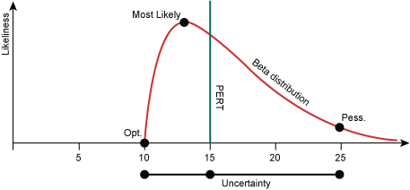  
  
  
Fairly satisfactory results for the most activities.   
  
Earliest Expected Time tE  
tE = (tO+4tm+tP)/6   
  
Std deviation σ = (tp-to)/6

**Crashing of Project**

In many situations it becomes necessary to cut down the project duration. How can it be done? Activities that are critical need be to be crashed in order to reduce project durations as it is these activities that determine the project duration. But this has got its own cost implications. Reduction in project duration calls for more resources to be pumped in and hence, the direct costs increase. Whereas indirect costs such as equipment, rent, supervision charges, etc. reduce. Thus, it becomes necessary to identify a project duration up to which the project can be crashed so that overall project costs are minimum.



Nt = Normal time

Nc = Normal cost

Ct = Crash time

Cc = Crash cost

**Project management performance**

When shall we consider a project a total success? Ideally, a project will be considered totally successful if it gets completed on time, within, budget and performs exactly to the designer’s specifications. Many projects would not meet these requirements. In real life, a project cannot be considered either a total success or a total failure it would fit somewhere in-between.

Performance indicators of PM

1. Time overrun

2. Cost overrun

3. Project sickness

4. Productivity as performance indicator

5. Value as performance indicator

**1. Time over run**

Time overrun is the non-completion of the project within the original or stipulates or agreed contract period.

Time overrun is one of the most significant issues being faced by the projects today. There are various factors responsible for the time overrun which require serious attention to understand and address in order to achieve successful completion of projects on time. This is because time overrun has great impact on cost which can never be recovered.

**2. Cost over run**

Time can be misquoted, cost cannot. Anything done to a project would be reflected in the cost. If a project is not managed well, its cost will go up., if a project is managed well, its cost should come down. Therefore, cost can be used as an indicator for project management performance. Cost estimates are to be revised at various stages to improve their accuracy.

**3. Project sickness**

The project management is responsible to best use of resources in the project in the project. The resources used for project reflect in the plant. The ratio of this out put to the cost incurred for putting up the plant could be an indicator of project management performance. This indicate the health of plant. If a project is implemented at a lower installed cost, the plant performance will be

so much better, if not, the plant faces the risk of falling sick. Installed cost per tonne is a performance indicator and commercial production cost per tonne is also an indicator. If both production cost and installed cost are not managed well the project fall sick.

**4. Productivity as performance indicator**

Productivity at the project implementation stage will affect the productivity of an operating plant. Operating cost per tonne reflects the productivity of an operating plant. A productivity

indicator reflects how resources have been utilized either for production of goods and services or for creation of facilities for the same.

**5. Value as performance indicator**

Value, which can be expressed as performance, improves only when performance is achieved as at no extra cost or when cost can be reduced for the desired level of performance.

If the installed cost per tonne of capacity is higher than normal, then the plant will invariably fall sick.

In fact, value engineering encourages increase in quality if it can be attained at no extra cost.

**DO-IT-YOURSELF TRAP**

Many owner would feel tempted to do everything themselves to bring down the project cost. In such cases, the owner engages the team of production to manage his project. He may try to get all the design work done in-house, fabrication as much as possible at his shop, engage labor contractors for construction and supervise the Design, procurement and construction work all by himself.

Unfortunately, these projects which have maximum time and cost overrun. They are also the ones where quality is ignored. The main drawback with this arrangement is that it imposes a tremendous load of coordination on a working group which has no experience nor is equipped with the tools and techniques of project coordination. Working team do not have the experience of working in an uncertain and dynamic work. This results in time and cost overrun for the project.

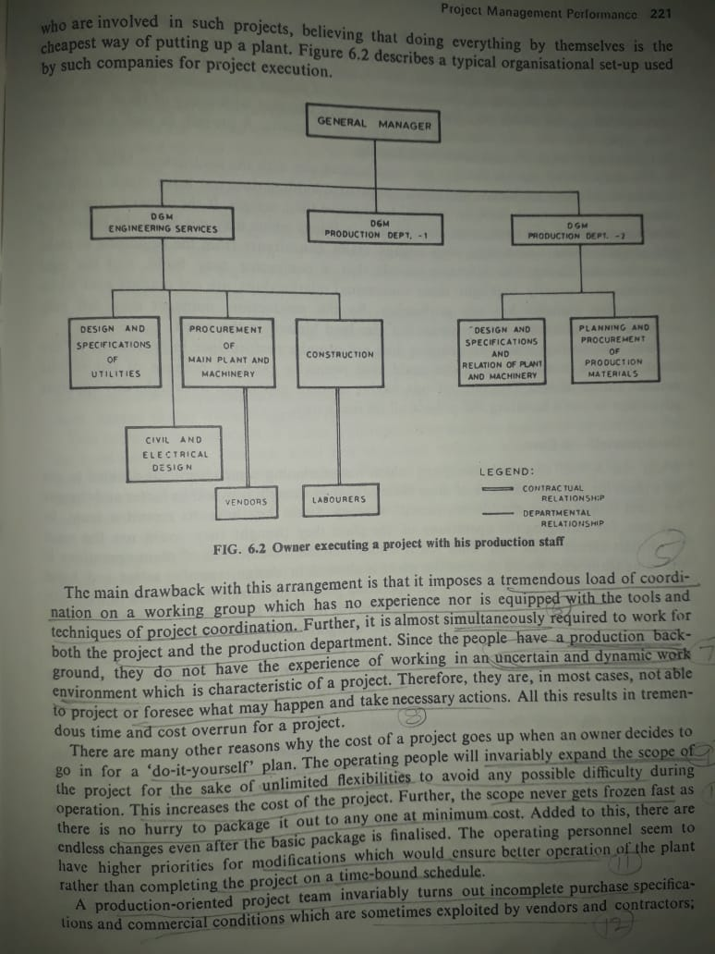

The operating people will invariably expand the scope of the project for the shake of flexibility to avoid any possible difficulty during operation. There are endless changes even after the basic package is finalized.

Contractor is enough to take the fun of “Do-it-yourself” type of management and unless some one intervenes, contractors are only interested in picking up payments. A project does not get completed easily and costs very heavily.

**Project Management Environment**

The project management environment in India, as shown in figure, is very different from other country. There are many problems experienced in the execution of both small and big projects.

The important problem is lack of mutual trust and respect amongst the participating agencies: owner, financial institutions, consultants, vendors and contractors.

The owner believes that the agencies would take him for a ride. Lack of professional ethics to the consultants. Most of procurement may often be selected purely on personal rather than techno-economic considerations.

The financial institution may not trust the owner since owner may disown a project and the financial institutions have more stake in the project than the owner himself.

Sometimes, owner may intentionally under estimate the project cost with the intension of reducing his contribution. So there will be cost overrun and time overrun for financial arrangement.

The project management environment in India, can broadly be grouped into four classes of environment problems:

Social

Economic

Technical

Managerial.

The figure details the problems which normally experienced during project execution in India.

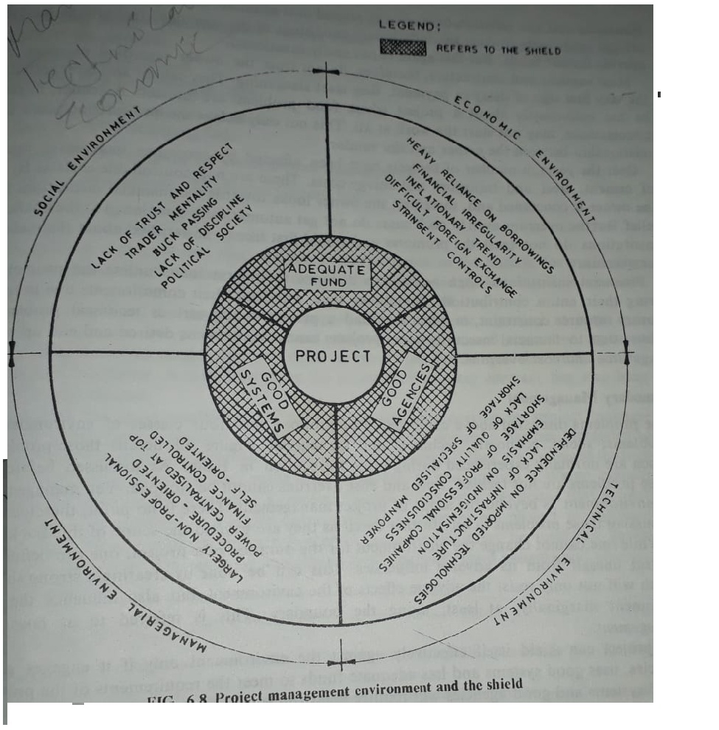

**Risk analysis**

Investment risk is the probability or likelihood of occurrence of losses relative to the expected return on any particular investment.  
  
Risk is inherent in almost every business decision .Different techniques have been suggested to handle risk in capital budgeting fall into two broad categories.  
   
 1) Technique that considers the stand-alone risk of a project.  
  
 2) Technique that consider the risk of a project in the context of the firm or in the context of the market.

Sources, Measures and Perspective on risks

Sources of risk:

1. Project - specific risk: This type of risk is specific to the project like the quality of management .
2. Competitive risk: This type of risk may be affected by the unanticipated actions of the compotators.
3. Industry - specific risk: Unexpected technology development and regulatory changes that are specific to the industry will causes risk.
4. Market risk : Unanticipated changes in macro economic factors like the GDP growth rate , interest -rate and inflection have an impact on all the projects.
5. International risk: In the case of foreign project, earnings and cash flows maybe different than expected due to the exchange rate risk or political risk.

Measures of risk

A variety of measures have been used to capture different facets of risk. These are: range, std. deviation, co-efficient variation and semi-variation.

**Range:** it is simplest measure of risk, the range of a distribution is the difference between the highest value and the lowest value.

**Std. deviation:** the std. deviation of a distribution is :

pi= Probability associated with i the value

Xi = ith value = expected value

**Co-efficient of variation (CV):** CV adjusts std. deviation for scale   
 CV = Std. deviation/expected vale  
**Semi variance:** The semi-variance is compared the way the variance is computed, except that only outcomes below the expected value are taken in to consideration



**Sensitivity analysis**  
Sensitivity analysis is technique for investigating the impact of changes in project variables on NPV or IRR.   
Only one adverse changes are considered in sensitivity analysis.   
  
Purpose of sensitivity analysis  
1. to identify the key variables which influences the project cost and benefit.  
2. to investigate the consequences of adverse changes by the variables on project by considering each key variables at a time.  
3. to identify the actions that could mitigate possible adverse effects on the project.

**Scenario analysis**

The variables are interrelated. So need of considering plausible (appearing) variables to study the effect of variables on project. Each scenario representing a consistent combination of variables.  
  
Steps involved in scenario analysis  
1. Select the factors around which scenarios will be built.  
2. Estimate the values of each of the variables in investment analysis for each scenario.  
3. Calculate NPV/IRR under each scenario.  
  
Best Scenario: High demand, high selling price, low variable cost and so on.  
Normal Scenario: Average demand, average selling price, average variable cost and so on.  
Worst scenario: Low demand, low selling price, high variable cost and so on.

**Break-even analysis  
Accounting break-even point**, on the one hand, is the easiest and most common method of analyzing profits. It is easily calculated by taking the [total expenses](https://corporatefinanceinstitute.com/resources/knowledge/accounting/fixed-and-variable-costs/) on a particular production and computing how many units of the product need to be sold in order to cover the expenses.  
  
**Financial break-even point**, on the other hand, It doesn’t address a specific product or units number, but instead, a company’s earnings, specifically about how much it needs to earn in order that its [earnings per share](https://corporatefinanceinstitute.com/resources/knowledge/finance/what-is-earnings-per-share-eps/) are equal to zero. Earnings mean the gross amount of money earned by the company before taxes and expenses are taken out.  
  
The term [contribution margin](https://corporatefinanceinstitute.com/resources/knowledge/accounting/contribution-margin-overview/) is often heard in relation to the break-even point. It refers to the actual profit a business can earn from every single unit sold. It is understood to be the product’s price, less the variable costs. Often, experts say the contribution margin shows the real profit and not the revenue.  
The formula for breakeven analysis is as follows:  
   
**Break even quantity = Fixed costs / (Sales price per unit – Variable cost per unit)**  
   
Where:  
**Fixed costs** are costs that do not change with varying output (e.g., salary, rent, building machinery).  
**Sales price per unit** is the selling price (unit selling price) per unit.  
**Variable cost per unit** is the variable costs incurred to create a unit.

**Hillier model of risk analysis**

According to the Hillier model, the risk associated with the project can be assessed through the standard deviation of expected cash flows. In other words, determining the viability of the project through calculating the deviations in the cash flows from the mean of expected cash flows.

Two cases of such analysis are

1. Uncorrelated cash flows
2. Correlated cash flows

**Uncorrelated cash flows:**  
In this type of investment in a project, there is no relationship between cash flows from one period to another

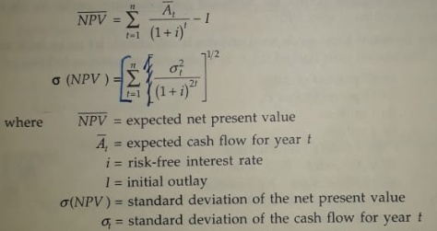

**Perfectly correlated cash flows**

If cash flows are perfectly correlated, the behavior of cash flows in all periods is alike. Cash flows of all years are linearly related to one another.

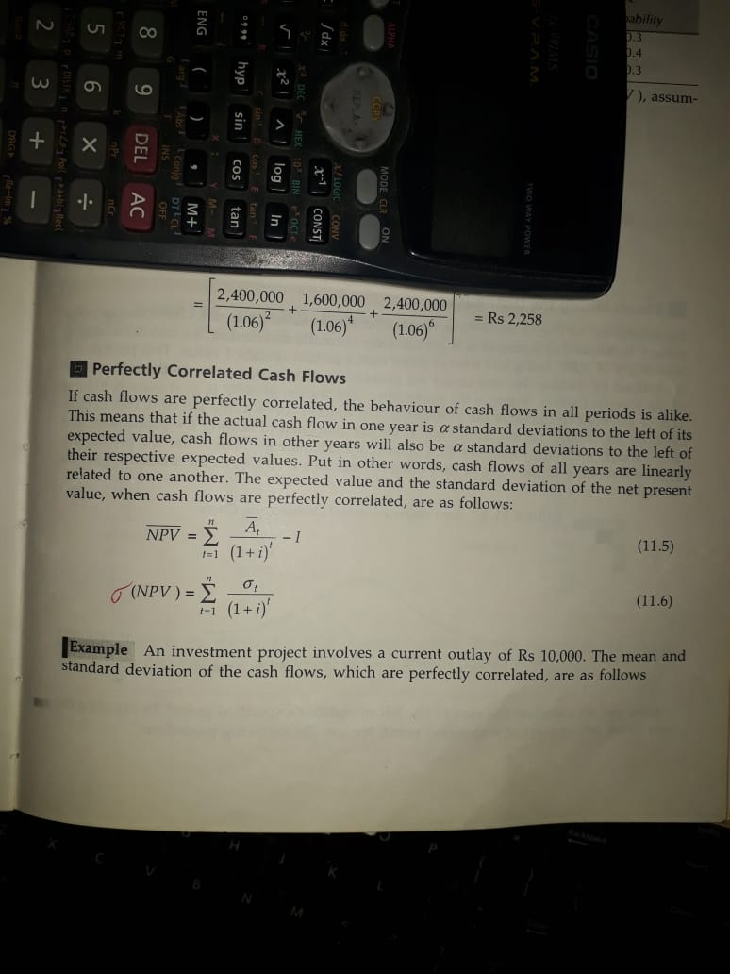

**Simulation analysis**  
The information can be generated by simulation analysis. Simulation analysis is a computer based exercise that generates large number of simulations and computes NPV of each of them to find out the distribution of NPV, its expected value and std. deviation as a measure of risk. Simulation analysis computes the probability distribution of NPV.   
  
Commonly used distributions are   
Uniform distribution, Trapezoidal distribution, step rectangular distribution, Normal distribution

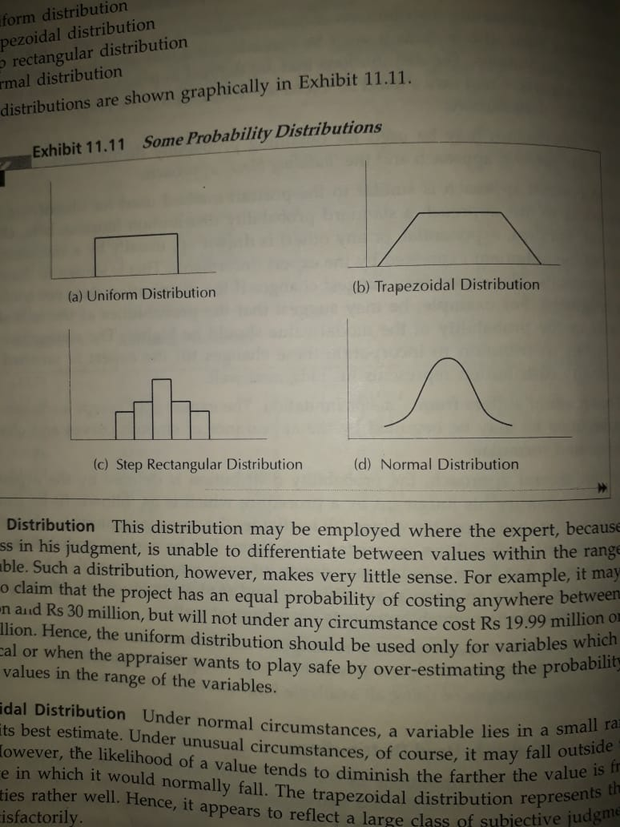

Steps involved in simulation analysis

1. Identification of exogenous variables that influence cash inflows and out flows of a project and its NPV.

Eg. Demand, selling price, variable costs, market size, market growth, variable and fixed cost etc.

2. Understanding the relationship among the variables and NPV.

Ex.

* Revenue depends on sales volume and price.
* Sales volume depends on market size and market share etc.

3. Specify the probability distribution of each of the exogenous variables.

1. Develop a computer programme that randomly selects one value from probability distribution of each variable and uses this value to calculate the project NPV.

**Decision tree analysis**  
A decision tree is a graphical representation of relationship between a present decision and future events, future decisions and their consequences. The sequence of events is shown in a format resembling branches of tree. The decision tree branches depict the cost and return associated with each branch and the probabilities are estimates for each possible outcome. The alternative with the highest amount of expected monetary is selected.

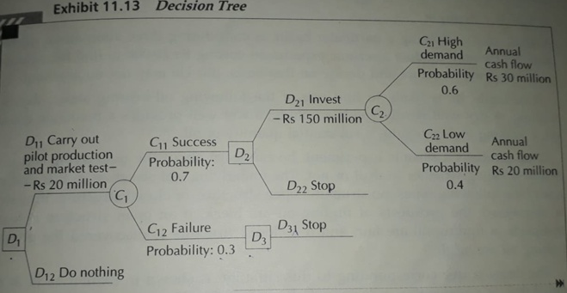

**Steps is decision tree analysis**  
1. **Identification of problem and alternatives:**

To understand the problem and to develop alternatives, information from different sources has been to be tapped. Imaginative efforts must be made to identify the nature of alternatives that may arise as the decision situation.

Recognizing that risk and uncertainty are inherent characteristics of investment projects.

2. **Delineating the decision tree:**

Constructing decision tree indicating decision points representing the various managerial courses of action available at a given point and following by the chance events that follow each action that impacts the future courses of action and is again followed by decision points.

**3. Specifying probabilities and monetary values for outcomes:**

Assignment of probabilities of chance events and determination of monitory values of cash inflows of each decision point.

These probabilities and cash flows are analyzed from the end to arrive at a judicious decision.

**4. Evaluating alternatives:**

The alternative decision with highest amount of expected monetary value is selected.

**Managing Risk**The managers want to explore ways and means of reducing risk. Some of the ways of doing this are given below:  
  
1. Fixed and variable cost: By increasing the variable cost and reducing the fixed cost, risk may be reduced. By buying the most of its components from a manufacturing and assembly company, fixed cost is reduced and increases is variable cost. The net effects is that its breakeven level declined.   
  
2. Pricing Strategy: A lower price increases potential demand, but also raises the breakeven point.  
  
3. Sequential investment: Firm is started with low investment, after knowing the mark response. Later expand as the market grows. This reduces risk exposure.   
  
4. Improving information: It is good to gather more information about the market and technology before taking the plunge. Additional study often improves the quality of forecasts but involves direct costs.   
  
5. Financial leverage: Reducing the dependence on debt (loan) lowers the risk. The debt entails a definite contractual commitment whereas equity carries no fixed burden.   
  
6. Insurance: Insurance covers a variety of risks like physical damage, theft, loss of key person, and so on. For insurance, we need to pay the insurance premium.   
  
7. Long-term arrangements: One way to mitigate risk is to enter into long-term arrangements with suppliers, employees, lenders, and customers.   
A long–term contract with suppliers ensures availability of inputs at predictable price.  
A long-term wage contract with employees removes uncertainty about employee cost.  
  
8. Strategic alliance: A strategy alliance is legal agreement between two or more companies to share or access to their technology, trademarks and other assets.   
   
9. Derivatives: Derivate instruments like options and futures can be used for managing risk.  
 An option gives its owner the right to buy or sell an underlying assets on or before a given date at a predetermined price.  
 A future contract is an agreement between two parties to exchange an assets for cash at a predetermined future date for a price that is specified today.

**Project Selection under Risk**Several methods are there to accept or reject a project proposal after gathering the information about expected return and variability on return.  
  
1.Judgemental Evaluation:   
 The decision , to accept or reject a project, is based on collective view of some group like, Board of Directors, the executive committee etc. without using any formal method of decision analysis.   
  
2. Payback period requirement: If the risk is function of time, a shorter payback period is required even if the NPV is positive. Lower the pay back period is better to come out from risk.   
  
3. Risk profile method: In this method, transform the probability distribution of the NPV into probability distribution of profitability index.   
 The higher the expected value of profitability index, greater the dispersion that is acceptable to the management.

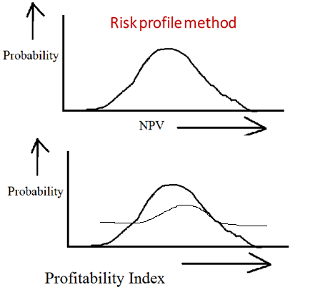

1. **Risk Adjusted Discount rate method**: The risk adjusted method calls for adjusting rate to reflect project risk. If the risk of the project is greater than the risk of the existing investments of the firm, the discount rate used is higher than the average cost of capital of the firm.



  
  
rk = risk adjusted discount rate for project k.  
i = risk free rate of interest  
n = adjustment for firm normal risk  
dk = adjustment for the differential risk of project k  
Once the project’s risk adjusted discount rate is specified, the project is accepted if its NPV is positive.

1. **Certainty equivalent method:**

Certainty equivalent co-efficients transform expected values of uncertain flows into their certainty equivalent.

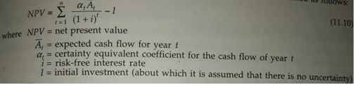

**Financing of Projects**

Project financing is a long-term, limited recourse financing solution that is available to a borrower against the rights, assets and interests related to the concerned project.

**Sources of finance**

Capital structure

Menu of financing

Equity capital

Preference capital

Internal accruals

Term loans

Debentures

Working capital advance

Miscellaneous sources

Raising venture capital

Raising venture capital in international market

**Capital Structure**

Two broad sources of finance available to a firm are

* + - * 1. Shareholder’s funds
        2. Loan funds

1. Shareholder’s funds are:

a) Equity capital and Retained earnings

b) Preference capital

2. Loan Funds are:

* 1. Debenture capital
  2. Term loan
  3. Deferred credit
  4. Fixed deposits
  5. Working capital Advance

**Difference between share holder’s funds(equity) and loan funds (debt)**

**Equity holder Debt holder**

1. Share holder have a residual claim on 1. have a fixed claim in the form of the income and the wealth of the firm interest and principal payment
2. Not a tax deductible payment 2. Interest paid to creditors is a tax deductible payment
3. Has an indefinite life 3. has a fixed maturity
4. Control the affairs of firm 4. play a passive role

**Important considerations in planning the capital structure are :**

1. Earning per share
2. Risk
3. Control
4. Flexibility
5. Nature of assets

1. Earning per share (EPS):

Earnings per share, which is simply equity earnings divided by the number of outstanding equity shares.

EPS= (Profit before interest and taxes-interest)(1-tax rate)-preference dividends

Number of equity shares

To expand firm, the management has to rise additional capital either by issuing equity shares or through debentures with some percent interest. Breakeven analysis is also carried out for the financing plans

2. Risk: The two principal sources of risk in a firm are

Business risk

Financial risk

Business risk refers to the variability of profit before interest and taxes.

It is influenced by the following factors:

* + Demand variability
  + Price variability
  + Variability in input prices
  + Proportion of fixed costs

Financial risk represents the risk emanating from financial leverage. If debt is in high proportion, it increases the fixed financial commitments. Equity shareholders face the risk in additional to the business risk.

3. Control: To enhance the additional capital for a firm, it may go for debt finance or a rights issue of equity capital, or combination of these. The control on firm depends on type of capital.

4. Flexibility: Flexibility refers to the ability of a firm to raise capital

from any source. It may be equity or debt capital. However debt equity ratio is normally not permitted to exceed a certain level. A firm does not fully exhaust its debt capacity. It implies that the firm maintains reserve borrowing power to enable it to raise debt capital to found unforeseen fund.

5. Nature of assets: If the assets of a firm is tangible (physical), their assets are debt.

If the assets are primarily intangible (brands and technical know how), debt finance is used less.

**Different ways of raising Equity and debt**

**Public and private sources of capital:**

Public and private sources of capital is available to a firm to raise equity and debt.

Public source is in the form of securities offered to the pubic through an offer document filed with the Securities Exchange Board of India(SEBI).

Private capital is in the form of loans given by banks and financial institutes or in the form of securities like equity shares, preference shares and debentures from investors like financial institutions, insurance companies, mutual funds and wealthy individuals.

**The typical pattern of financing:**

When a company is formed, it first issues equity shares to the promoters (Founders) and also, raises loans from banks, financial institutions and other sources. As the need for financing increases , the company may issue shares and debentures privately to promoter’s relatives, friends, business partners, employees, financial institutions, banks, mutual funds, venture capital funds and others.

As the company grows further, it may have the rise capital from the public.

Apart from the equity shares, a firm may issue preference shares and debentures to the general investment to public through a public issue.

**Equity capital**

Equity capital represents ownership capital as equity share holders.

The equity share holders are the owners of the company who have significant control over its management. They enjoy the rewards and bear the risk of ownership. The equity capital is also called as the share capital or equity financing.

**Some terms**

Authorized capital: it is the maximum amount of capital that a company can raise through the issue of shares to the shareholder.

Issued capital: The issued capital refers to the number of shares issued by the company to the shareholders.

Subscribed capital: The part of issued capital which has been subscribed to by the investors represents the subscribed capital.

Paid-up capital: The actual amount paid up by the investors is called paid-up capital.

Par value: of an equity share is the value stated in the memorandum and written on the share scrip.  
Par value generally Rs. 10.  
  
Issue price: is the price at which the equity share is issued. An existing company may some times set its issue price higher than the par value.  
  
Book value : Paid-up equity capital + Reserves and surplus-intangibles  
 No. of outstanding equity shares  
  
Market value: of an equity share is the price at which it is traded in the market

**Rights of equity share holders**

**Rights to income:**

The equity investors have a residual claim to the income of the firm. The equity shareholders are entitled to dividend that is declared by the Board of Director

**Right to control:**

Equity share holders as owners of the firm elect the Board of Directors and have the right to vote on every resolution placed before the company. Board of directors selects the management which controls the operations of firm.

**Pre-emptive right:** The pre-emptive right enables exiting equity share holders to maintain their proportional ownership by purchasing additional equity shares issued by the firm. Equity share holder has the right to purchase additional share with first preference.

**Right in liquidation:** As in the case of income, equity shareholders have a residual claim over the assets of the firm in the event of liquidation. The claims of all other-debenture holder and preferred share holder-are settled prior to the firm of equity share holders.

**Methods of raising equity capital**

When a company is formed, it first issues equity shares to the promoters (Founders)

And to the selected group of investors.

As the company grows, following are methods of raising equity shares:

1. Initial public offering (IPO) 2. Seasoned offering

3. Rights issues 4. Private placement

5. Preferential allotment

**1. Initial public offering**

The first public offering of equity shares of a company, which is followed by

a listing of its shares on the stock market, is called the initial public offering.

Benefits of IPO are

1. Access larger pool of capital
2. Respectability
3. Lower cost of capital compared to private placement.
4. Liquidity

**2. Seasoned offering**

As company grow, they are likely to make further trips to the capital market with issues of debt and equity.

The procedure for a public issue of seasoned offering is similar to that of an IPO.

**3. Rights issue**

When a company issues additional equity capital, it has to be offered in the first instance to the existing shareholders on a pro rata basis. This is required under Section 81 of the companies Act 1956.

**4. Private placement**

It is refers to sale of equity of an unlisted company or sale of debentures of a listed or listed company to sophisticated investors such a financial institutions, mutual funds banks etc.

**5. Preferential allotment**

An issue of equity by a listed company to selected investors at a price which may or may not be related to the prevailing market price is referred to as preferential allotment in the Indian capital market.

**Advantages of equity capital to the company**

1. There is no compulsion to pay dividends.
2. Equity capital has no maturity date.
3. Larger the equity base, the greater the ability of the firm to raise debt

finance on favorable terms.

1. Equity dividends are tax-exempt up-to a certain extent.

**Disadvantages of equity capital to the company**

1. Sale of equity shares to outsiders dilute the control of existing owner.
2. The cost of equity capital is high.
3. Equity dividends are paid out of profit after tax.
4. Cost of issuing shares is generally higher than the cost of issuing other types of securities.

**Preference capital**

Preference capital is hybrid form of financing. It has characteristics of equity and debentures.

**Some characteristics of equity shares**

1. Profit is distributed.
2. Not an obligatory payment.
3. Not a tax-deductable payment.

**Some characteristics of debentures**

1. Divided rate is fixed.
2. Claim is prior to the equity share holder.
3. Do not enjoy the right of vote.

**Advantages of preference capital to the company**

1. There is no legal obligation to pay preference dividend.
2. There is no liability in the case of perpetual preference shares.
3. It is the part of net worth.
4. No voting rights, so no dilution of power.
5. No collateral is pledged for preference share.

**Disadvantages**

1. More expansive than debt capital.
2. Skipping dividends can adversely affect the image of the firm in the capital market.
3. Prior claim than the equity share holders.
4. If a firm skips preference dividends for three years, it has to grant voting rights to the preference shareholders.

**Term Loan**

The firms obtain long term debt mainly by raising term loans or issuing debentures for private firms and public firms.

Term loan is referred as term finance, loan is generally repayable is less than

10 years with equal installments.

**Features of term loans**

Currency

Security

Interest payment and principal repayment

Restrictive covenants

**Currency:** Financial institutions give rupee term loan and foreign currency term loan. The rupee term loans are given directly for buildings, preliminary expenses, working capital etc.

Financial institutions provide foreign currency term loan for meeting the foreign currency expenditure towards import of plant, machinery etc.

**Security:** Usually assets, which are financed with the term loan, provide the prime security. Other assets of the firm may serve as collateral security. All loans provided by financial institution with interest, liquidated damages, commitment charges, expenses etc. are secured by the way of

1. Equitable mortgage for immovable properties of the borrower.
2. Hypothecation of all movable properties of the borrower.

**Interest payment and principal repayment:** Typically, term loans provided by financial institutions are repayable in equal instalments. This installments includes interest and part of principal. Interest burden is decline over time.

The borrower has to pay principal with interest irrespective of the financial situation of the firm.

Financial institutions impose a penalty for defaults and in this case borrower is liable to pay compound interest and other additional charges.

**Restrictive covenants:** Financial institutions impose restrictive conditions on the borrowers. This conditions depends on nature of project and financial situation of the borrower.

1. Obtain clearances and licenses from various govt. agencies.
2. Repay existing loans with the concurrence of the financial institutions.
3. Refrain(stop) from undertaking any new project or expansion without

prior approval. Refrain from additional borrowings.

**Term loan procedure**

1. **Submission of application:** The application submitted for term loan covers

the following:

* + - * Promoters background
      * Particulars industrial concern
      * Particulars of the project
      * Cost of the project
      * Means of financing
      * Marketing and selling arrangements
      * Profitability and cash flow
      * Economic considerations
      * Govt. consent

**2. Initial processing of loan applications:** Officers of the financial institution reviews it to ascertain whether it is complete for processing. If it is incomplete asked to give required information. Then they prepares “Flash report”. Flash report is Summarization of loan application.

**3. Approval of the proposed project:** Approval covers the marking, technical, financial, managerial and economic aspects. Based on this a decision is taken to accept or reject.

**4. Issue of the letter of sanction:** If the project is accepted, a financial letter of sanction is issued to the borrower. This communicates to the borrower in terms and conditions.

**5. Acceptance of the terms and conditions by the borrowing unit:** the acceptance of the terms and conditions has to be conveyed to the financial institution with in a stipulated period

**6. Execution of loan agreement:** After the acceptance from the terms and conditions by the borrower, the agreement is executed as per the Indian stamp Act 1899, along with other documents. Once the financial institution signs the agreement, it becomes effective.

**7. Creation of securities:** The term loan and the deferred payment provided by the financial institutions ate secured through mortgage of immovable properties and hypothecation of movable properties.

**8. Disbursement of loan:** Periodically, the borrower is required to submit information on physical progress of the project. Based on the information provided by the borrower, the financial institution will determine the amount of term loan to be disbursed from time to time.

**9. Monitoring:** Monitoring of the project is done at the implementation stage as well as at operation stage through:

* + Regular reports- which provide information about placement order etc.
  + Periodic visits
  + Discussion with promoters, banker etc.
  + Progress reports
  + Audited accounts of the company.

**Project Appraisal**

Financial institutions appraise a project from the marketing, technical, financial, economic and managerial angles.

**Market Appraisal:** Examine the reasonable demand projections by utilizing the demand findings of available surveys , industry association projections, planning commission projections, and independent market survey.

**Technical appraisal:** This focuses on product mix, capacity, process of manufacture, raw materials, location and site, building etc.

**Financial appraisal:** Seeks to assess: Reasonableness of the estimate of capital cost, Reasonableness of the estimate of working results, Adequacy of rate of returns, Appropriateness of the financing pattern

**Economic appraisal:** The economic appraisal looks at the project from the larger social point if view. It referred to as social cost benefit analysis.

**Managerial appraisal:** In order to judge the managerial capabilities of the promoters, the following questions are raised:

1. How resources are the promoters?
2. How sound is the promoters’ understanding of the project?
3. How committed are the promoters?

**Debentures**

Debentures are the instruments for raising debt finance from public. Debenture holders are the creditors of a company. For large publicly traded firms, debentures are a viable alternative to term loans.

**Features of debentures.**

a) When a debenture issue is sold to the investing public, a trustee is appointed through a trustee deed.

b) Debenture issues in India are typically secured by mortgages/charges on the

immovable properties of the company.

c) Debentures are typically redeemable in nature.

d) Debenture maturity period of less than 1 year (short term debentures), 1year – 5 year (medium tem) and 5 year -12 year (long term).

e) Publicly issued debentures that have a maturity period of 18 months or more.

f) Debentures may carry a fixed rate of interest or floating rate of interest or zero rate

of interest.

**Innovations in debentures**

**Deep discount bond:** A deep discount bond is a form of bond, which is issued at

significant discount to its face value. It records a promise by its issuer of the bond to pay the bond holder, on the stated maturity date, an amount which is greater than the amount originally received.

**Convertible debentures:** A convertible debentures is a debenture that is convertible,

partially or wholly, into equity shares. SEBI guide lines are followed during the

Conversion. Convertible debentures are commonly used all over the world.

**Floating rate bonds:** Convertible bonds carry a fixed rate of interest. Floating rate bonds earn an interest rate that is linked to a benchmark rate such as the Treasure bill interest rate.

**Secured Premium Notes (SPN):** After getting approval from the Central Govt, SPN are issued by listing company. These are non-convertible debentures issued by the companies with the lock-in-period. SPN holder will get principal amount with interest on installment basis after the lock-in-period.

**Indexed bond:** The payoff of a typical indexed bond consists of two parts. The first part represents a fixed amount and second part represents a variability component whose value is linked to some index.

**Private placement of debentures**

Private placement implies any offer or invitation to subscribe or issue debentures by a company to a certain category of listed financial institution through private placement offer-cum application letter. The principal buyers of privately placed debentures, insurance company, army group insurance, Navy group insurance and so on.

***Accessibility of private placement of debenture:*** Almost every company can access the private placement market. The private placement market can accommodate issues of smaller size whereas the public issues of market does not permit an issue below a certain minimum size.

***Flexibility:*** In a private placement, there are greater flexibility in working out the terms of issue. For example, when a non-convertible debenture issue is privately placed, a discount May be given to institutional investors to make the issue attractive.

***Speed:*** A private placement issue of debenture requires lesser time than the public issue cycle. An elaborate procedure followed in a public issue is largely bypassed in private placement.

***Lower issue costs:*** The issue of debentures in private placement is substantially less compared to public issue. Because, public issue entails the expenses like brokerage, printing, promotion and so 0n.

**Working capital advance**

**Cash credits/overdraft:** Under a cash credit or over draft arrangement, a pre-determined limit of loan for borrowing is specified by the bank. Whenever required the borrower can draw cash within the limit. He can also repay the amount, partially or fully, as and when desires.

Interest is charged only on the running balance, not on the limit sanctioned. A minimum charge may be payable irrespective of the level of borrowing for availing of this facility.

**Loans:** These are advances of fixed amounts to the borrower. The borrower is charged with interest on the entire loan amount, irrespective of how much he draws.

**Purchase/Discount of bills:** A bill arises of a trade transaction. The bill may be payable after a usance period. The seller offers the bill to the bank for discount/purchase. When the bank purchase the, it releases the funds to the seller. The bank present the bill to the purchaser on the due date and gets its payment.

**Letter of credit:** This document will be issued by the bank of the buyer to the bank of seller guarantying to pay the agreed amount of money to the other as specified in the letter of credit.

**Miscellaneous sources**

Apart from regular sources of finance, there are several other ways in which finance may be obtained.

1. Deferred credit
2. Lease and hire-purchase finance
3. Unsecured loans and deposits
4. Special schemes of institutions
5. Subsidies and sales tax deferments and exemptions
6. Short-tem loans from financial institutions
7. Commercial paper

**Deferred credit:** Many time the supplier of machinery provide credit facility under which payment for the purchase of machinery is made over a period of time.

Normally, the supplier of machinery when he offers deferred credit facility insists that a bank guarantee should be furnished by the buyer.

**Lease finance and Hire purchase:** A lease represents a contractual arrangement whereby the lessor (owner) grants the lessee the right to use an asset in return for periodic lease rental payments. Leasing of industrial equipment is a relatively recent phenomenon, particularly on the Indian scene.

Hire purchase is an arrangement made while buying expensive goods. The consumer makes a down payment during the purchase and the outstanding balance will be paid in installments with an interest charge.

**Unsecured loan and Deposits :** Unsecured loans are a type of funding, which is offered without the applicant having to provide any collateral to the bank. These unsecured loans are offered on the basis of an applicant’s financial documents, credit score, income etc.

Deposits from the public represent unsecured borrowing of one to three years duration. Many existing companies prefer to raise public deposits instead of term loans from financial institutions because restrictive covenants do not accompany public deposits.

**Special Schemes of institutions:**

1. Bill rediscounting scheme: Under this scheme, the seller realizes the sale proceeds by discounting the bills accepted by the buyer with a commercial bank which in turn rediscount them with the financial institutions.
2. Supplier line of credit: Under this arrangement, the bank directly pays to the machinery manufacturer against usance bill duly accepted or guaranteed by the bank of purchaser.

**Subsidies and sales tax deferments and exemptions:** Government and development agencies may provide subsidies for certain kind of Projects. The central govt as well as the state govt provided subsidies to industrial units located in backward area.

To attract industries, the state provide incentives in the form of sales tax deferments and sale tax exceptions.

**Short-term loans from financial institutions:** Financial institutions provide unsecured short-term loans for a period of one year (renewable) to companies with a good track record. To be eligible for such a loan, a company must satisfy certain conditions relating to dividend track record, debt-equity ratio, current ratio and interest coverage ratio.

**Commercial paper:** A commercial paper represents short-term unsecured promissory notes is issued by firm while enjoy a fairly high credit rating. Maturity period of a commercial paper ranges from 90 to 180 days.

Commercial paper is sold at a discount from its face value and redeemable at its face value.

Commercial paper is directly placed with investors who intend holding it till its maturity.

**Venture capital**

Startup companies with a potential to grow need a certain amount of investment.

Such investment is provided by venture capital funds. Venture capital represents

Financial investment in a risky proportion made in the hope of earning a high

rate of return.

**Preparing a business Plan:**

Some guideline to approach venture capitalist to finance your project:

1. Use simple and clean language during presentation and avoid technical terms.
2. Focus on four basic elements Viz. People, product, market and competition.
3. Give projections for about two to five years with emphasis on cash flows.
4. Identify risks and development of strategy to cope with the same.
5. Convince them that the management team is talented, experienced, committed

and determined.

**Raising capital in International market**

Indian firms can raise capital from

Euromarkets

Domestic markets of various countries

Export credit

**1. Euromarkets:** Euromarkets refers to a collection of international banks that help firms in raising capital in a global market which is beyond the purview of any national regulatory body. An Indian firm can access the Euromarkets to raise a

Eurocurrency loan

Issue of Eurobonds

Issue global depository receipts

Eurocurrency loan are often syndicated loan, where a group of lenders, particularly banks, participate jointly in the process of lending under a single loan agreement. The syndicate of lender is represented by the lead bank.The rate of interest on Eurocurrency loans is a floating rate and usually linked to

LIBOR (London Interbank offer Rate) or

SIBOR(Singapore Inter Bank offer rate)

**Eurobonds**: Firms using Euromarkets can sell bonds:

1. Eurobond is issued outside the country in whose currency is denominated.
2. Managed by syndicate of investment bank.
3. It is bearer bond. Unregistered payable bond to any person.
4. The interest on it is usually paid annually or half-years.

**Global depository receipts:** Indian companies have issued global depositary receipts (GDR), which indirectly equity investment, in the Euromarkets. The underlying shares called depositary shares. A company planning a GDR issue must obtain the approval from the ministry of finance and FIPB (Foreign Investment Promotion Board)

1. **Foreign Domestic Market**

It is a way to raise money internationally is to sell securities directly in the domestic capital market of foreign countries. This is referred to as direct issuance. Indian firms can issue bonds and equities in the domestic capital market of a foreign country.

**3. Export credit schemes**

Export credit agencies have been established by the government of major Industrialized countries for financing exports of capital goods and related technical services.

Two kinds of export credits are provided : Buyer’s credit and supplier’s credit.

Under buyer’s credit scheme, credit is provided directly to the Indian buyer for

purchase of capital goods and technical services from the overseas exporter.

Supplier’s credit scheme, in which credit provided to the overseas exporters

so that they can make available medium-term finance to Indian importers.